1. **Develop a Spring MVC project with JPA and implement the JPA repository for CRUD operations.**
2. **Develop a simple MVC project with JPA and implement a JPA Entity User for handling the data from the user interface to the database.**
3. **Implement code for Implementing Generic Exception handling for all Resources with matching user friendly error messages.**
4. **Write a code to implementing POST Methods for User Resource to send the JSON request to the rest API and test the DELETE operation with a resource.**
5. **Implement code to Enhancing exception handling with POST Method to return correct HTTP Status Code and Location to the user for successful data creation.**
6. **Develop a Spring MVC project with JPA and implement a JPA Entity User for handling the data from the user interface to the database.**

**Solutions :**

1. **Develop a Spring MVC project with JPA and implement the JPA repository for CRUD operations**

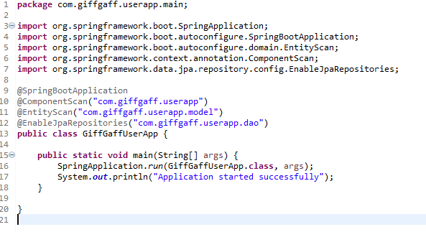

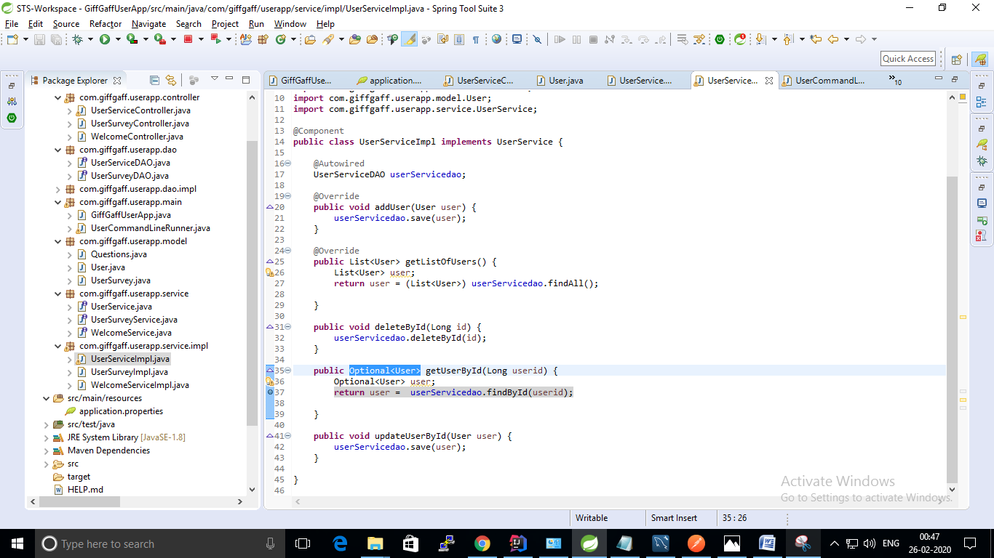

1. **Develop a simple MVC project with JPA and implement a JPA Entity User for handling the data from the user interface to the database.**

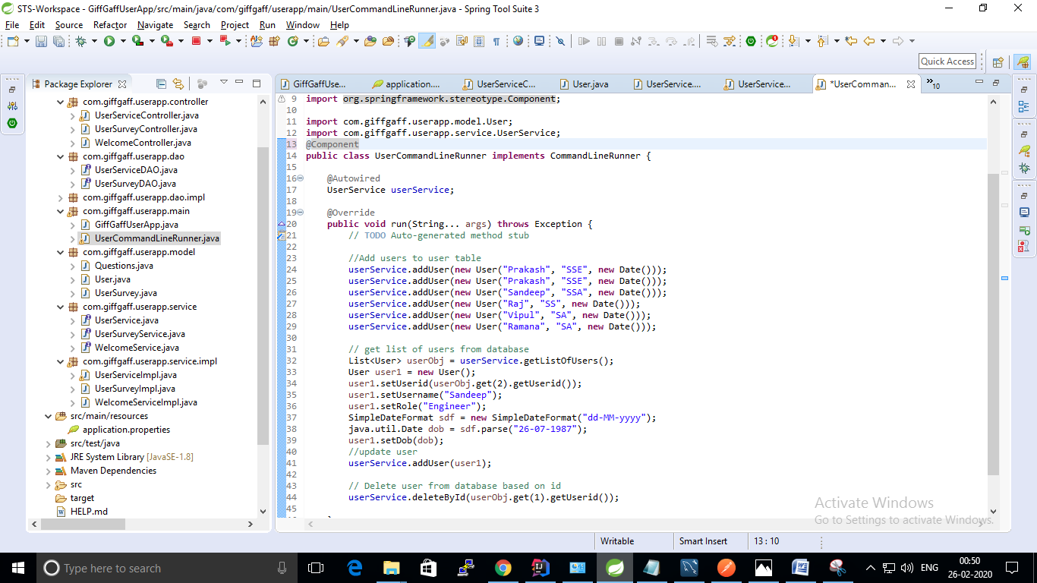

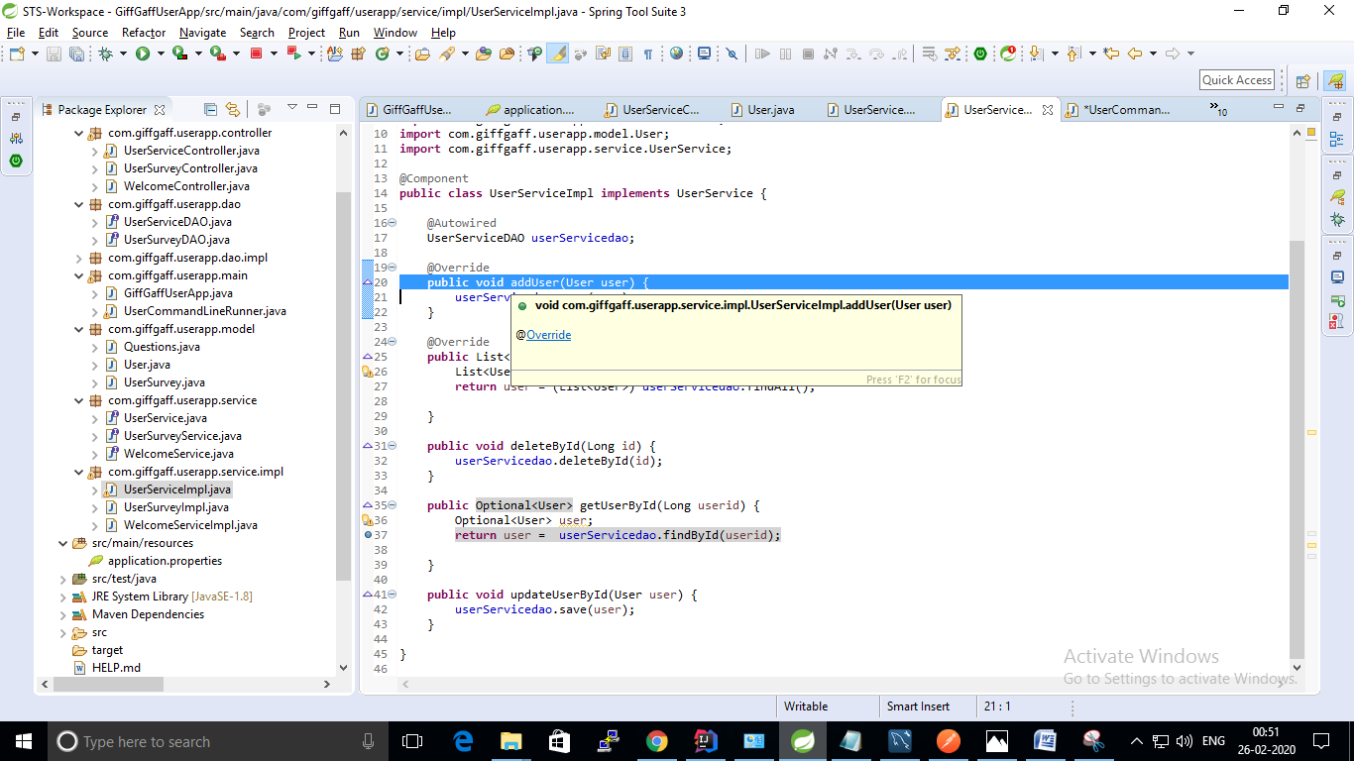

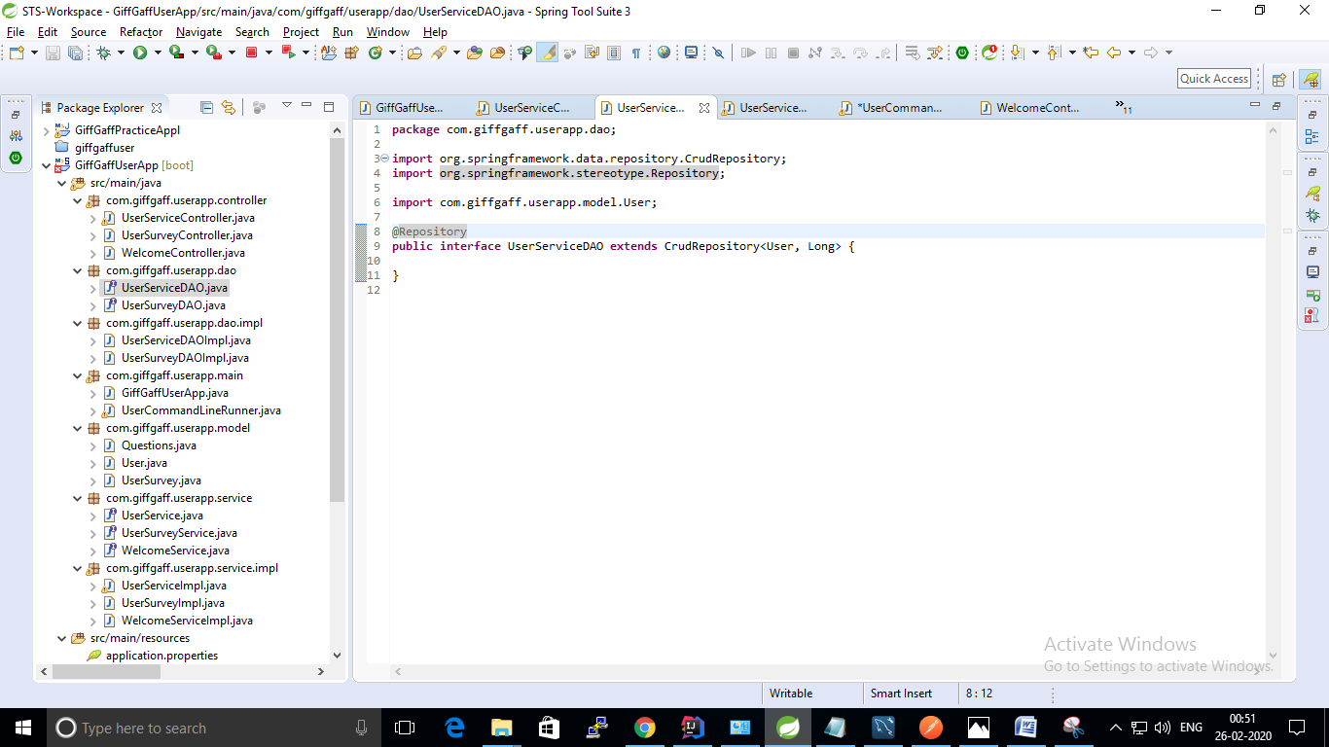

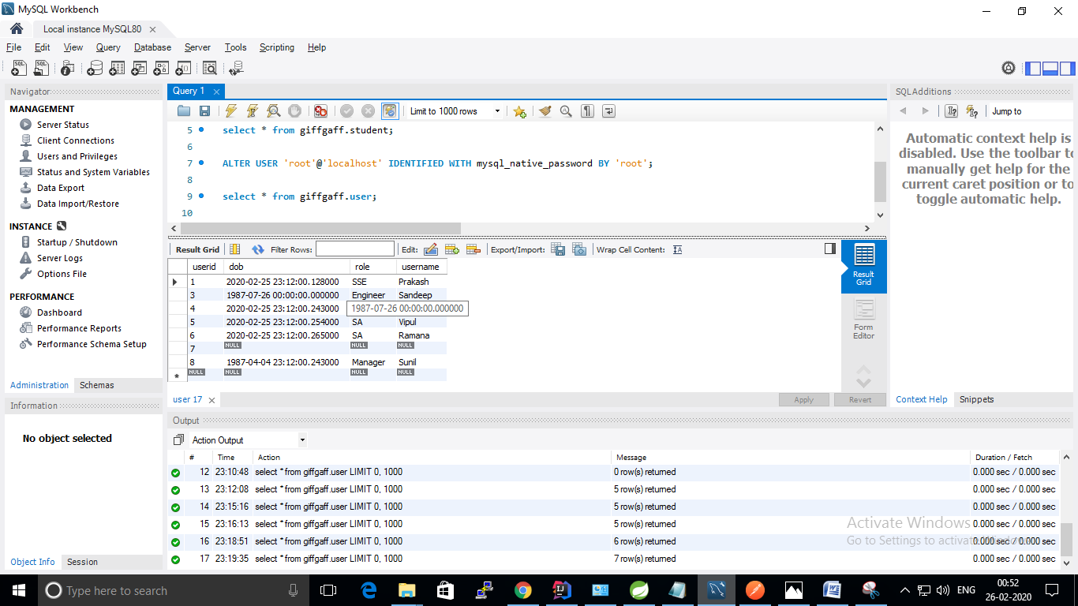

1. **Implement code for Implementing Generic Exception handling for all Resources with matching user friendly error messages.**

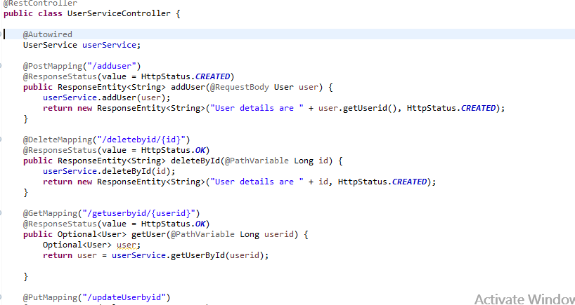

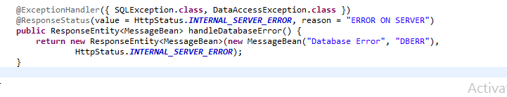

1. **Write a code to implementing POST Methods for User Resource to send the JSON request to the rest API and test the DELETE operation with a resource.**

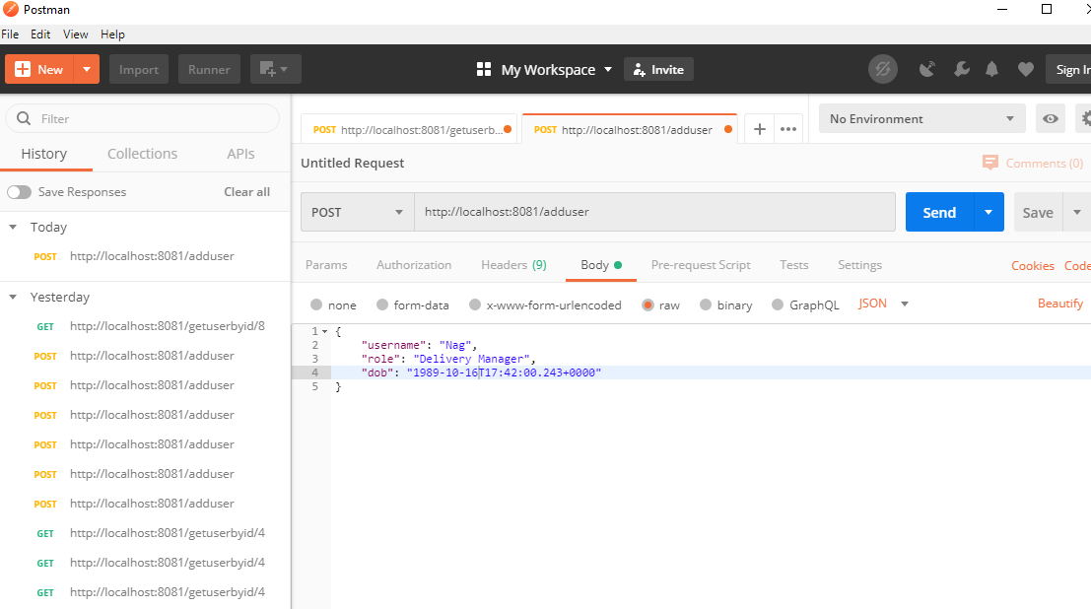

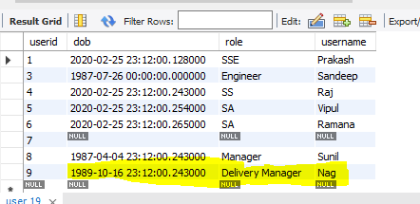

**Test Delete Operation: I am going to delete userid:6 through Postman**

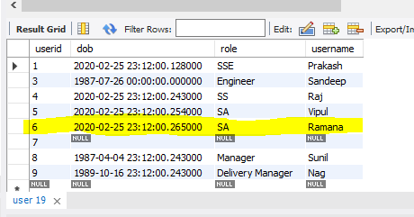

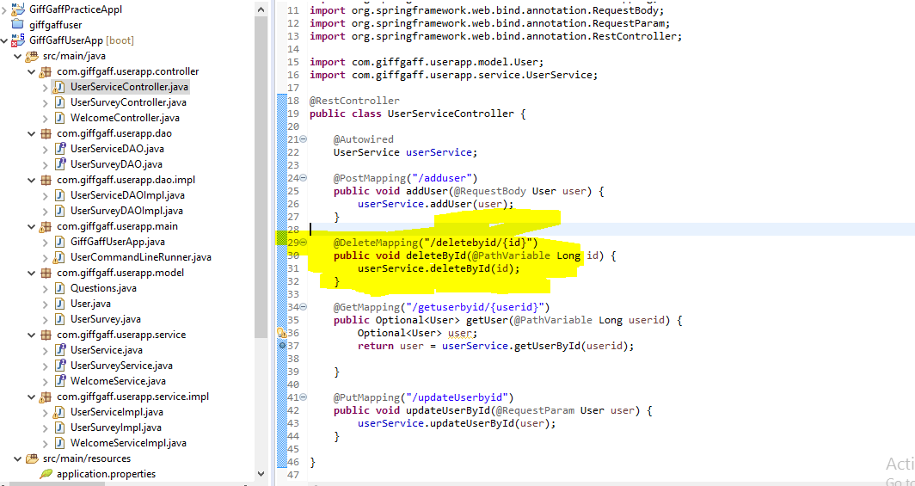



**Deleted Userid:6 from database. Refer below screenshot .**

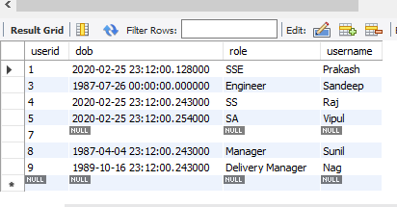

1. **Implement code to Enhancing exception handling with POST Method to return correct HTTP Status Code and Location to the user for successful data creation.**

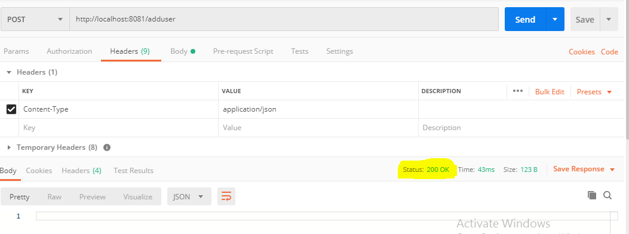

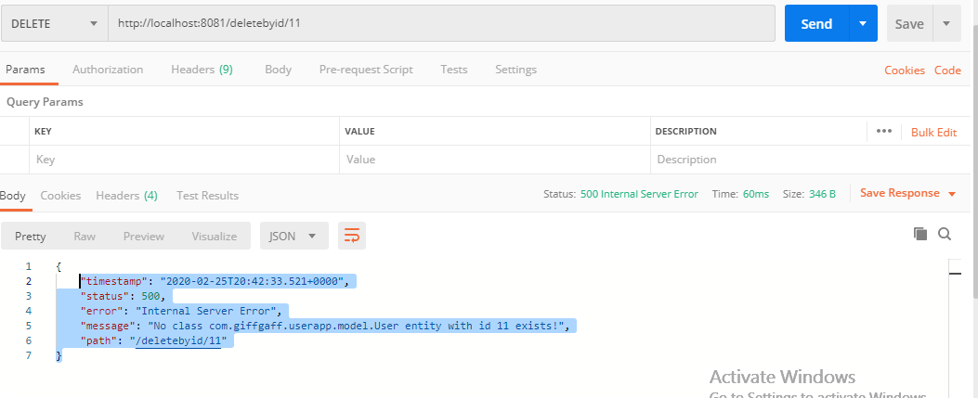

1. **6th question is same as 2nd question.**